Lab 3 - Routing Protocol

NAME: WOO CHENG SHUAN
MATRIC NYM.: A23CS0283
SECTION: 12

INTRODUCTION
This lab looks into the network layer, focusing on subnetting and routing.

TOPOLOGY

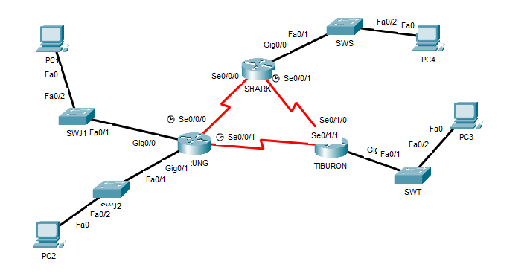

LAB INFORMATION
Here is some basic information for the lab. The network address given is 172.18.110.0/23.
Table 1

Device | Subnetwork | Usable Hosts
JERUNG | LAN1 | 20
 | LAN2 | 30
SHARK | LAN | 60
TIBURON | LAN | 50
Connections | JERUNG-SHARK | 2
 | JERUNG-TIBURON | 2
 | SHARK-TIBURON | 2

Table 2

# | Device  Name | Interface | IP Address | Subnet Mask | Gateway
1 | JERUNG | Se0/0/0 | 172.18.110.193 | 255.255.255.252 | -
2 |  | Se0/0/1 | 172.18.110.197 | 255.255.255.252 | -
3 |  | G0/0 | 172.18.110.129 | 255.255.255.224 | -
4 |  | G0/1 | 172.18.110.161 | 255.255.255.224 | -
5 | TIBURON | Se0/1/1 | 172.18.110.198 | 255.255.255.252 | -
6 |  | Se0/1/0 | 172.18.110.202 | 255.255.255.252 | -
7 |  | G0/0 | 172.18.110.65 | 255.255.255.192 | -
8 | SHARK | Se0/0/0 | 172.18.110.194 | 255.255.255.252 | -
9 |  | Se0/0/1 | 172.18.110.201 | 255.255.255.252 | -
10 |  | G0/0 | 172.18.110.1 | 255.255.255.192 | -
11 | PC1 | - | 172.18.110.158 | 255.255.255.224 | 172.18.110.129
12 | PC2 | - | 172.18.110.190 | 255.255.255.224 | 172.18.110.161
13 | PC3 | - | 172.18.110.126 | 255.255.255.192 | 172.18.110.65
14 | PC4 | - | 172.18.110.62 | 255.255.255.192 | 172.18.110.1

LAB TASKS

Task 1 – IP Addressing
- Given the network address of the organisation and the basic information provided in both Tables 1 and 2. Show your workings here and complete Table 2 with the correct information. PCs will be given the last usable address of the subnetwork.
- Using the IP addresses calculated, configure the devices with the appropriate information.
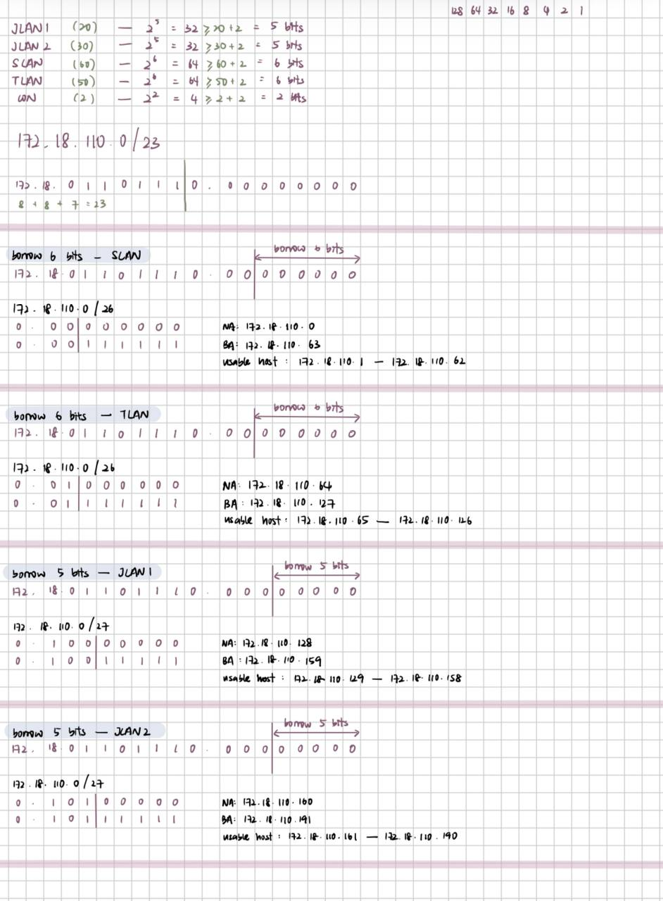
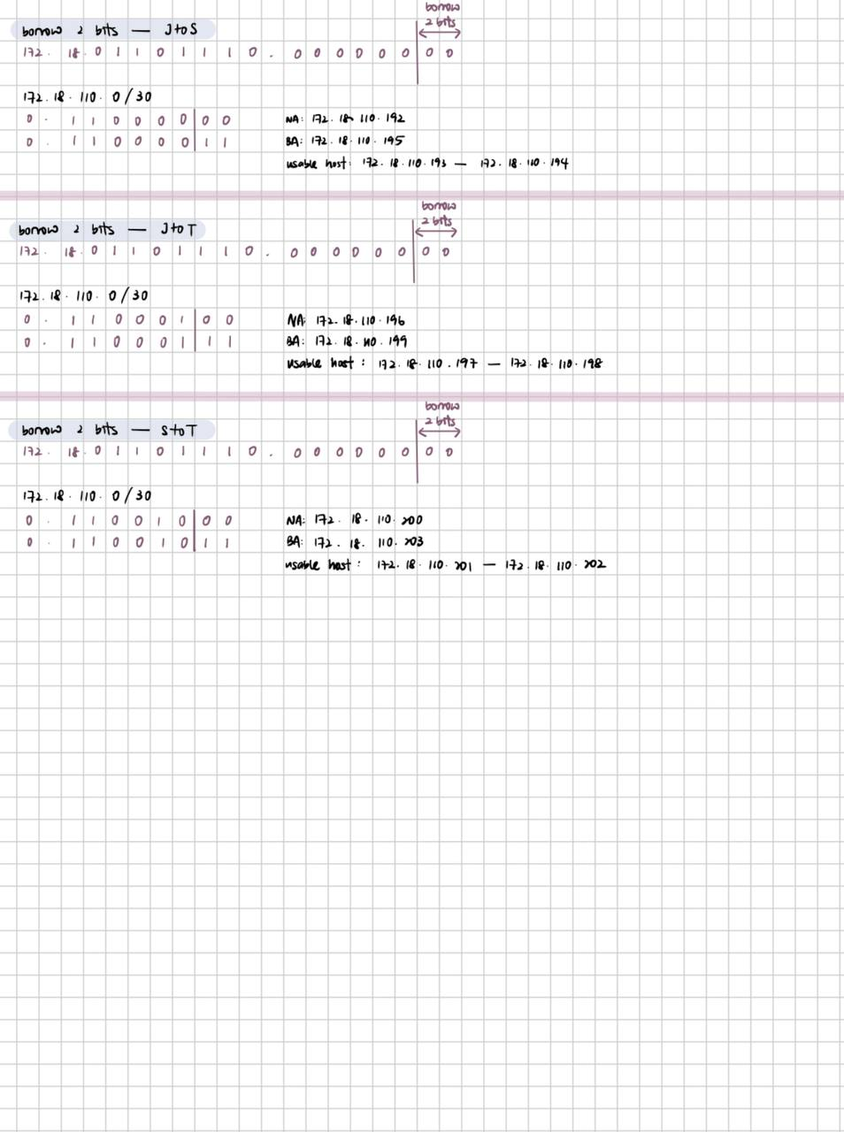

Task 2 – Routing Table
- Paste the current routing table of each router here. There are 2 ways to this – via CLI and via Packet Tracer (PT) tool. Use both ways to show the routing table of all the routers.
  - CLI
    - Click on a router. In the prompt, type show ip route. The routing table of the router will be shown, as shown in Figure A.
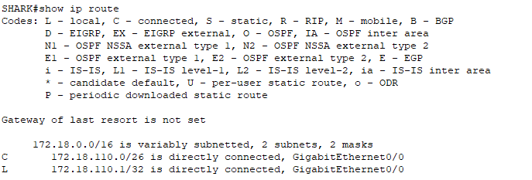
Figure A
ANS:
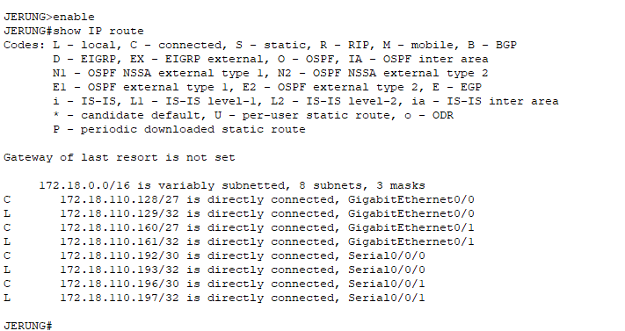
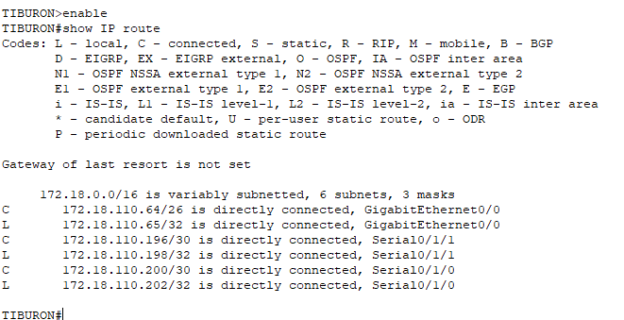
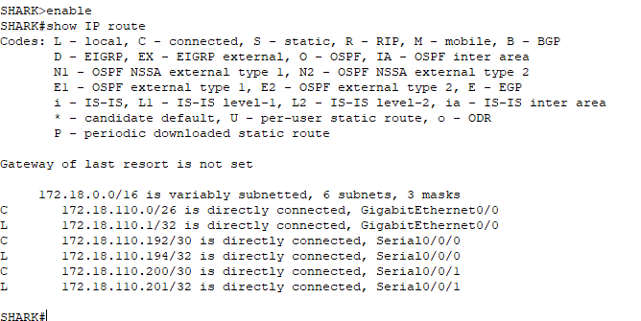

  - PT tool
    - Click on the magnifying glass (shown in Figure B), then click on a router, then choose Routing Table. A sample of the result is shown in Figure C.

Figure B
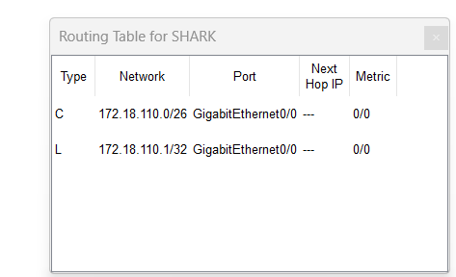
Figure C
ANS:
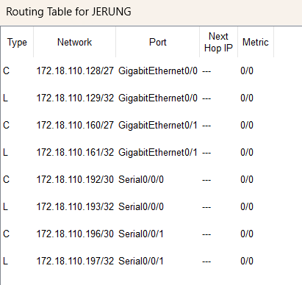
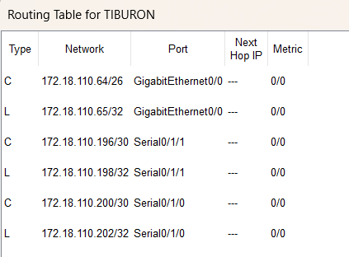
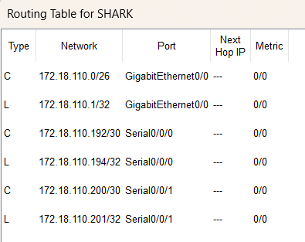
- Try to ping PC2 from PC1, paste the results here.
ANS: SUCCESS

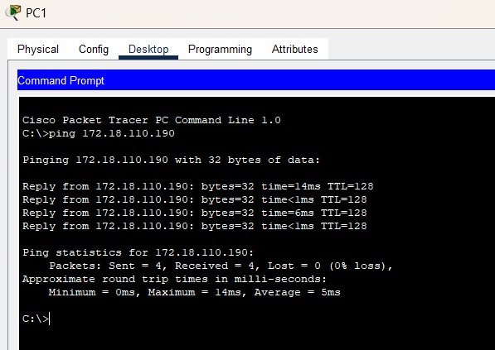
- Try to ping PC4 from PC1, paste the results here.
ANS: FAIL
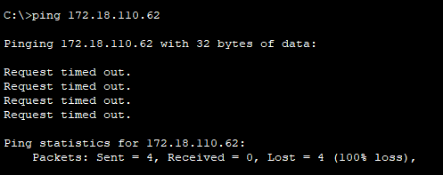

- Explain the reason(s) behind the results.
ANS: Ping PC1 and PC2 is successful because they are in same subnet which is JERUNG. However ping PC1 and PC4 is fail because they are not in the same subnet.

- What needs to be done to ensure all PCs can ping each other successfully?
ANS: We need to configure the routers with the proper routes to include all network segments to ensures that the routers know how to forward traffic in between the PCs.

Task 2 – Routing Configuration
- Let’s start by opening the routing table (using the PT tool) for TIBURON and JERUNG. This is done to show changes to the routing table as configurations are made.
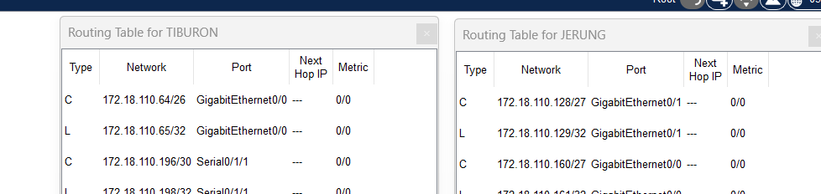
Figure D
- In router JERUNG, configure the RIP routing protocol as shown in Figure E.
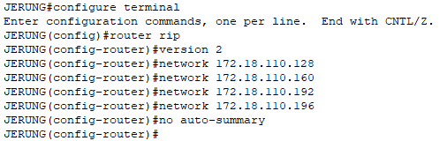
Figure E
  - What can you say about the addresses used in the ‘network’ instructions in Figure E?
ANS: The addresses used in the 'network' instructions is the network address of router JERUNG. They also act as the router information of JERUNG.

- Then configure RIP in TIBURON. All are similar except use the network address. Use the instructions as shown below.
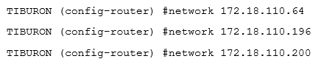
- As you may have seen, there are changes in the routing tables of both TIBURON and JERUNG. Paste a copy of these routing tables here.
ANS:
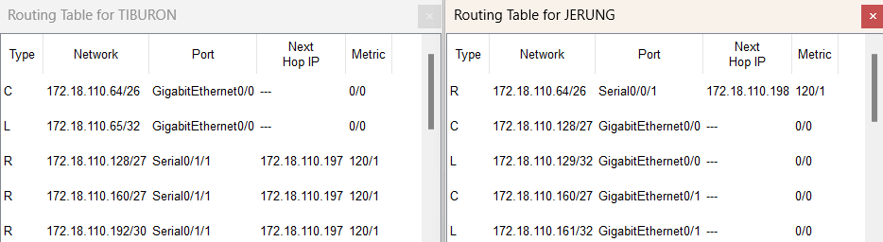

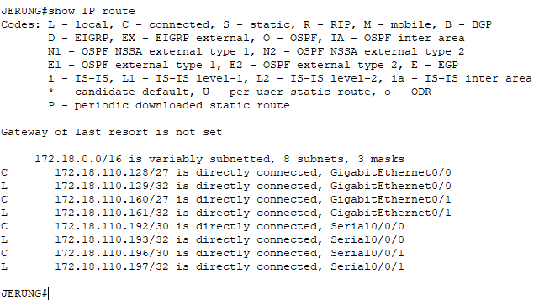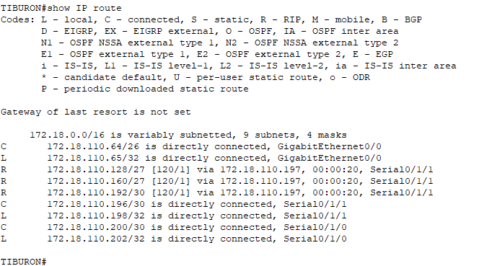

  - What are the changes seen in TIBURON?
ANS: RIP protocol generated new routes and are added to the routing table marked with a “R” for RIP.

  - What are the Networks with type R in TIBURON and JERUNG?
ANS: The networks with type R in TIBURON and JERUNG are Routing Information Protocol (RIP). RIP is used to manage router information in a self-contained network such as a corporate LAN or a private WAN. They will automatically be updated in the routers’ routing table.

  - Ping PC3 from PC1. Was it successful?
ANS: SUCCESS
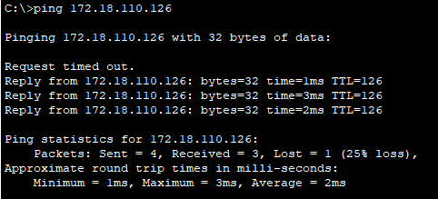

  - Ping PC4 from PC1. Was it successful?
ANS: FAIL
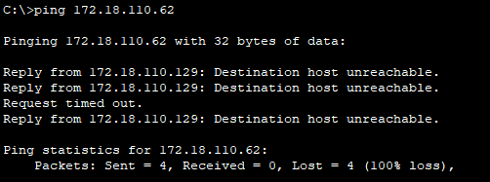

  - Explain the reasons for your answer.
ANS: The ping from PC1 to PC3 is successful because the network connection between them is correctly configured and the routes are set up to allow the communication. RIP routing protocol of JERUNG for PC1 and TIBURON for PC3 have properly setup and configured then automatically be updated in the routers’ routing table. However, the ping from PC1 to PC4 is not successful because the network connection between them and routing table for SHARK are not properly configured.
  - Continue with configuration of RIP in SHARK. Paste your configurations here.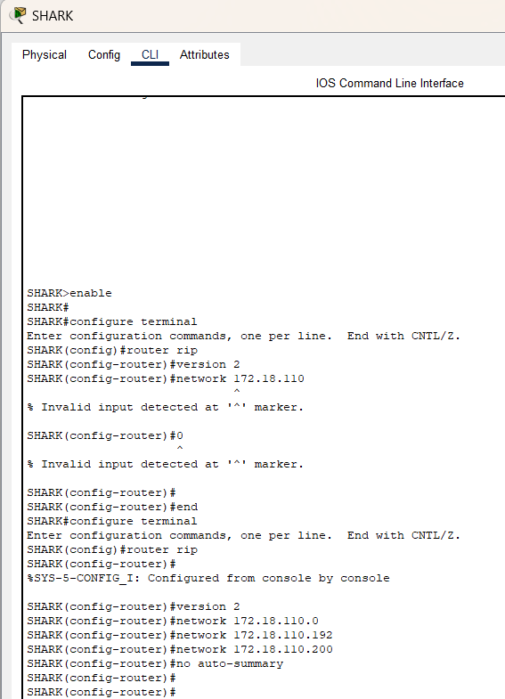

  - Open router SHARK’s routing table and paste here.
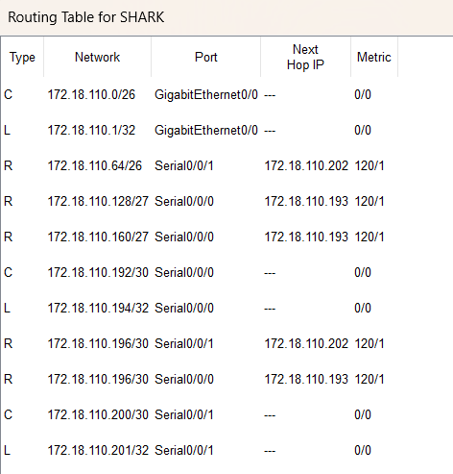

  - Try to ping from PC4 to all other PCs in the topology. *Note: Try to ping at least twice to get best results.
PC | Ping result
1 | SUCCESS  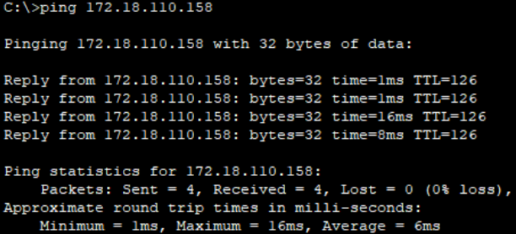
2 | SUCCESS  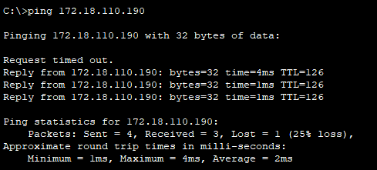
3 | SUCCESS  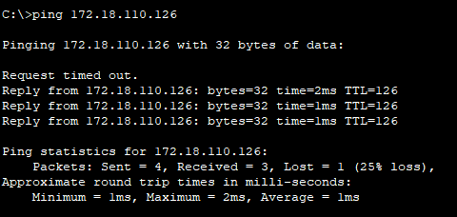

Task 3 – Routing Update
- Let’s try a little experiment. Change the IP addresses of router TIBURON interface G0/0 to 192.168.1.1/24.
  - This means that the subnet has changed. Find the new Network address of this subnet. Network Address is: 192.168.1.0/24

  - As this change happens, PC3 must also have different IP address, subnet mask and gateway address. What will it be?
PC3 | Info
IP address | 192.168.1.254
Subnet Mask | 255.255.255.0
Gateway Address | 192.168.1.1

  - After this change, can PC4 and PC1 ping PC3?
ANS: FAIL
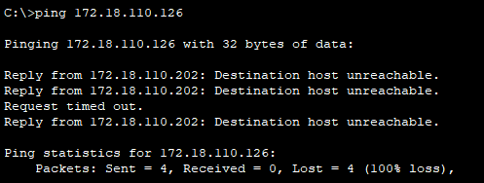
ANS: FAIL
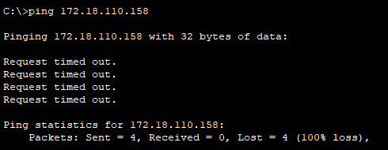

  - Copy and paste the routing tables for both SHARK and TIBURON here.
ANS:
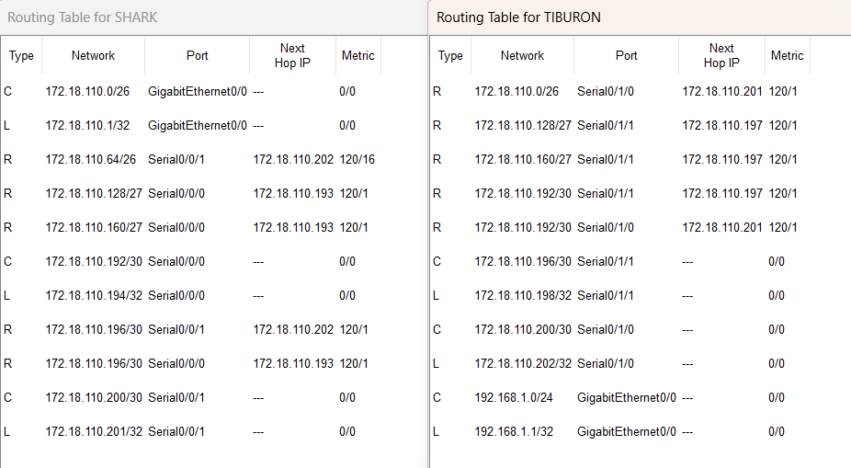

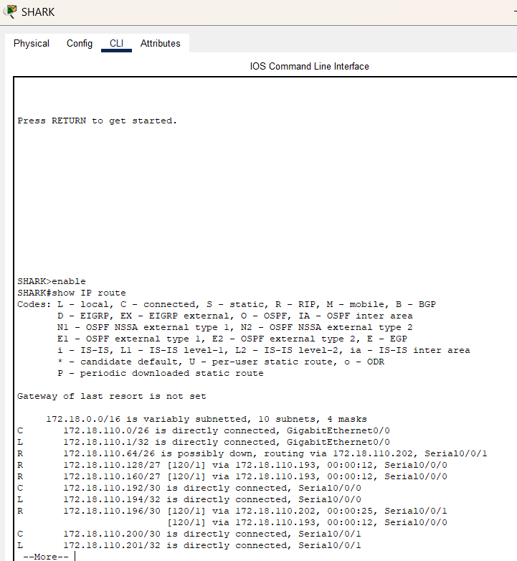
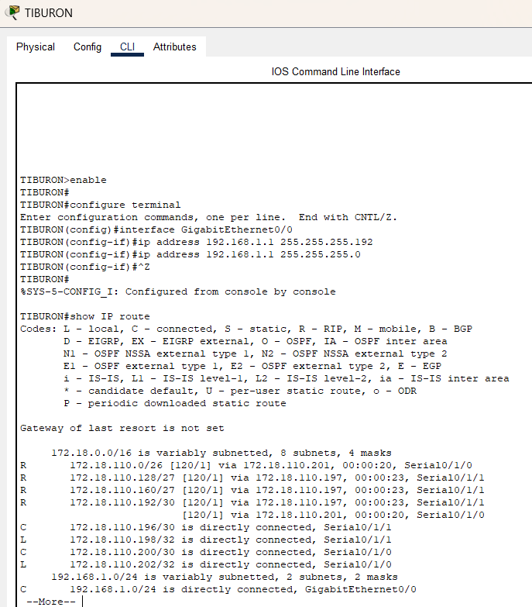

  - Referring to the routing table, explain your findings.
ANS: The new network address of the subnet has not updated into the routing table. Therefore, it causes all the packets that destinated for PC3 to be dropped. Thus, PC4 and PC1 cannot ping PC3 after changing the new IP address.

  - What is your next move to ensure end-to-end connectivity (i.e. all PCs can ping each other successfully)?
ANS: My next move to ensure end-to-end connectivity is to update the routing configurations in TIBURON to include the new subnet (192.168.1.0/24) and advertise it using the RIP protocol to ensure that it can be updated into the TIBURON routing table automatically.

  - Show your configurations in TIBURON to ensure end-to-end connectivity.
ANS:
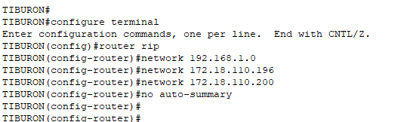

  - To ensure end-to-end connectivity, ping to all the PCs from PC3.
PC | Ping result
1 | SUCCESS  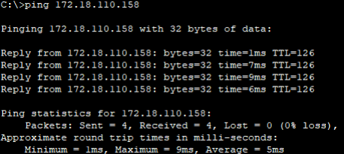
2 | SUCCESS  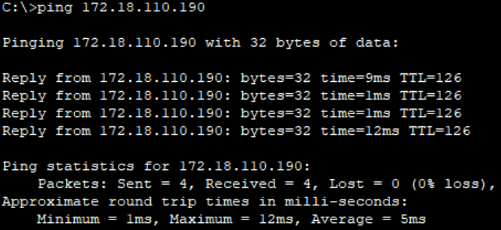
4 | SUCCESS  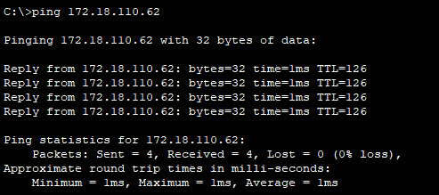

REFLECTION
What have you learned in this task?
ANS: In this task, I learned the importance of subnetting, routing protocols and proper configuration for maintaining network connectivity. I also learned how to allocate IP addresses, configure routers using RIP and update routing tables to reflect network changes. Troubleshooting failed connections highlighted the need for careful setup and verification. In a nutshell, the tasks emphasized adaptability and precision in managing and troubleshooting networks.

